**DAILY ONLINE ACTIVITIES SUMMARY**

|  |  |  |  |  |  |  |  |  |
| --- | --- | --- | --- | --- | --- | --- | --- | --- |
| **Date:** | **11-06-2020** | | | | | **Name:** | **Shetty Disha Ravindra** | |
| **Sem & Sec** | **VI B sec** | | | | | **USN:** | **4a17cs087** | |
| **Online Test Summary** | | | | | | | | |
| **Subject** | | - | | | | | | |
| **Max. Marks** | | - | | **Score** | | | - | |
| **Certification Course Summary** | | | | | | | | |
| **Course** | Capgemini Most Asked Aptitude Questions | | | | | | | |
| **Certificate Provider** | | | **-** | | **Duration** | | | 1hr |
| **Coding Challenges** | | | | | | | | |
| **Problem Statement:** 1] Write a python function that converts a string to all uppercase, provided it contains at least 2 uppercase characters in the first 4 characters. | | | | | | | | |
| **Status:executed** | | | | | | | | |
| **Uploaded the report in Github** | | | | | **Yes** | | | |
| **If yes Repository name** | | | | | **Disha_Shetty** | | | |
| **Uploaded the report in slack** | | | | | **Yes** | | | |
| **PYTHON ASSIGNMENT PROGRAM**  **1**] **Python Program to find the average of all Items in a Dictionary**  Screenshot (91).png | | | | | | | | | |

Online Test Details: (Attach the snapshot and briefly write the report for the same)

Certification Course Details: (Attach the snapshot and briefly write the report for the same)

Coding Challenges Details: (Attach the snapshot and briefly write the report for the same)

Online test

Certification progress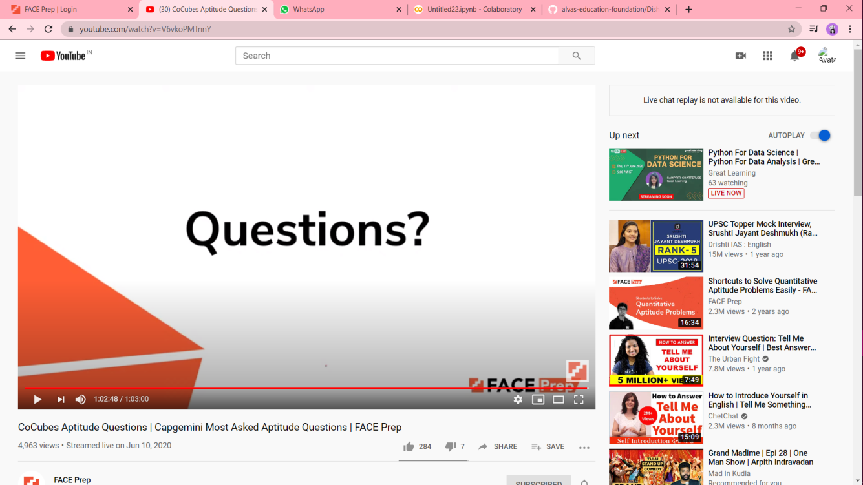

Coding challenge output

1]